**DAILY ONLINE ACTIVITIES SUMMARY**

|  |  |  |  |  |  |  |  |  |
| --- | --- | --- | --- | --- | --- | --- | --- | --- |
| **Date:** | **26/05/2020** | | | | | **Name:** | **Lavanya D M** | |
| **Sem & Sec** | **4th & ‘A’** | | | | | **USN:** | **4AL18CS041** | |
| **Online Test Summary** | | | | | | | | |
| **Subject** | | **DAA** | | | | | | |
| **Max. Marks** | | **30** | | **Score** | | | **24** | |
| **Certification Course Summary** | | | | | | | | |
| **Course** | **Git tutorial for beginners** | | | | | | | |
| **Certificate Provider** | | | **Bitdegree** | | **Duration** | | | **48hr** |
| **Coding Challenges** | | | | | | | | |
| **Problem Statement:1)** Given an array A of size N where the array elements contain values from 1 to N with duplicates, the task is to find total number of subarrays which start and end with the same element  2)write a program in c to print the all the permutation of string in pointer 3)remove 10 in given array | | | | | | | | |
| **Status:complied** | | | | | | | | |
| **Uploaded the report in Github** | | | | | **Yes** | | | |
| **If yes Repository name** | | | | | <https://github.com/lavanyamurthi/lockdown-coding>  <https://github.com/lavanyamurthi/lockdown-coding/blob/master/subarray%20start%20and%20end%20with%20same%20element.java> | | | |
| **Uploaded the report in slack** | | | | | **Yes** | | | |

Online Test Details: (Attach the snapshot and briefly write the report for the same)

<https://github.com/lavanyamurthi/lockdown-coding/blob/master/subarray%20start%20and%20end%20with%20same%20element.java>

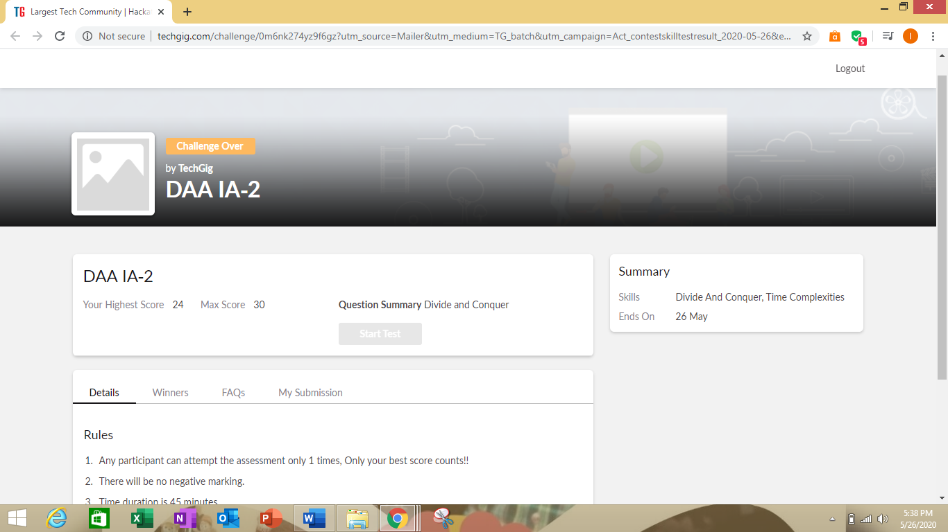

Certification Course Details: (Attach the snapshot and briefly write the report for the same)

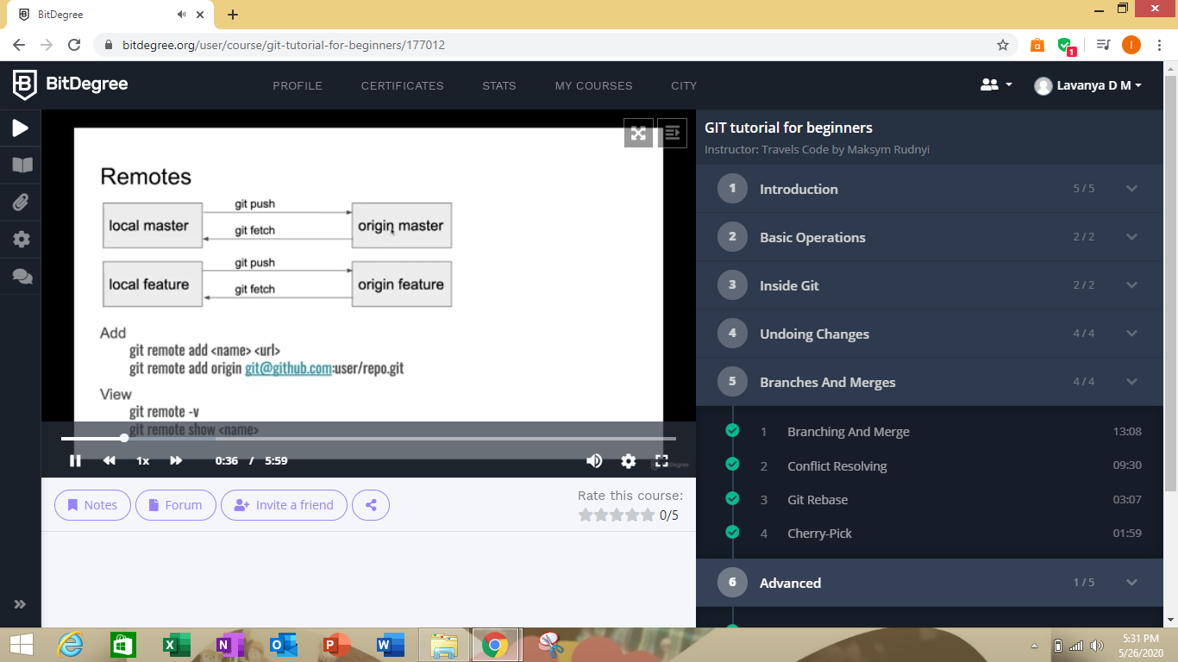

Here I’m learning about the git its branches ,merging and more advance

Coding Challenges Details: (Attach the snapshot and briefly write the report for the same)

Problem1:

Return a version of the given array where all the 10's have been removed. The remaining elements should shift left towards the start of the array as needed, and the empty spaces a the end of the array should be 0. So {1, 10, 10, 2} yields {1, 2, 0, 0}. You may modify and return the given array or make a new array.  
Example  
withoutTen([1, 10, 10, 2]) → [1, 2, 0, 0]  
withoutTen([10, 2, 10]) → [2, 0, 0]

Input: First line should read number of array elements. Second Line should read the array elements which includes atleast two 10.

Output: Array which contains elements without 10. Refer the examples

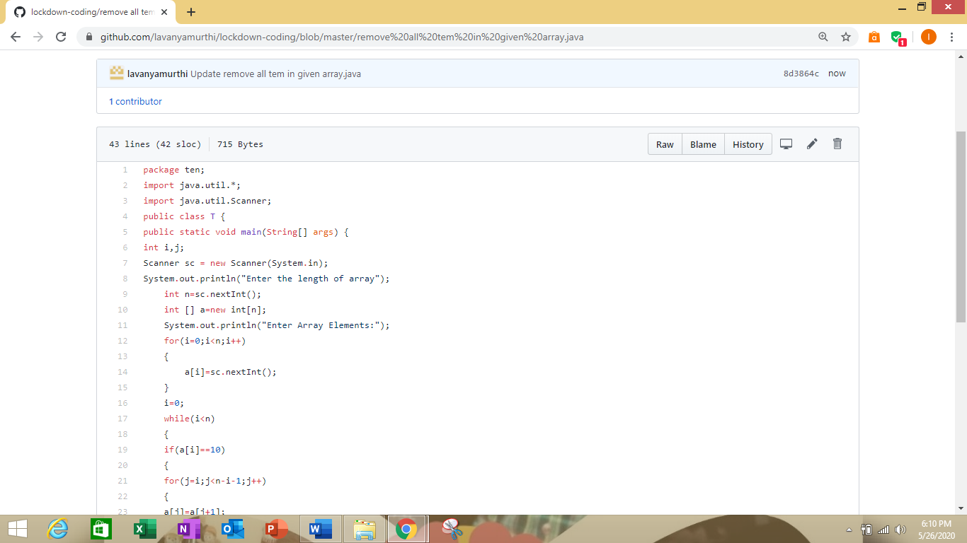

<https://github.com/lavanyamurthi/lockdown-coding/blob/master/remove%20all%20tem%20in%20given%20array.java>

Problem 2:

**Input:**  
Enter the Input String: abcd

**Expected Result:**

The permutations of the string are :  
abcd abdc acbd acdb adcb adbc bacd badc bcad bcda bdca bdac cbad cbda cabd cadb cdab cdba dbca dbac dcba dcab dacb dabc.

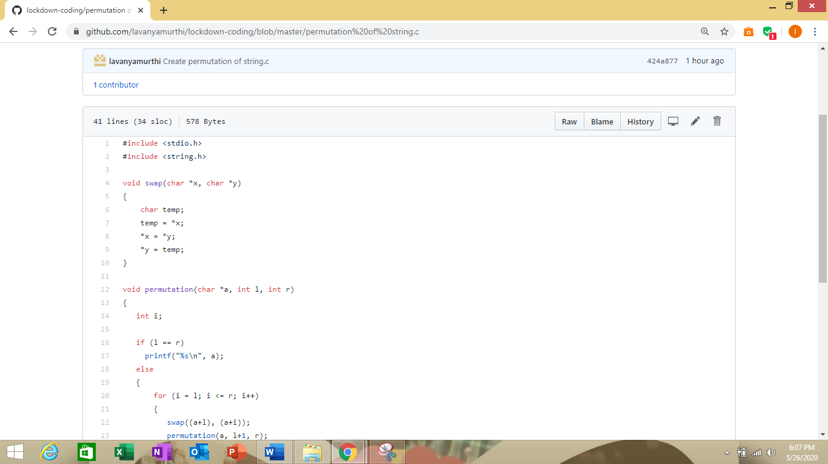

<https://github.com/lavanyamurthi/lockdown-coding/blob/master/permutation%20of%20string.c>

**Problem 3:**

Input: A[] = {1, 2, 1, 5, 2}  
Output: 7  
Explanation:  
Total 7 sub-array of the given array are {1}, {2}, {1}, {5}, {2}, {1, 2, 1} and {2, 1, 5, 2} are start and end with same element.

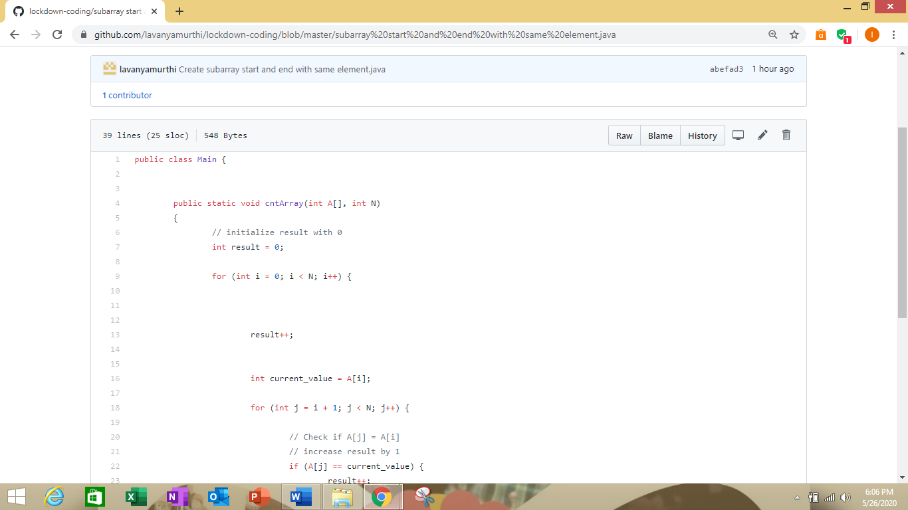

<https://github.com/lavanyamurthi/lockdown-coding/blob/master/subarray%20start%20and%20end%20with%20same%20element.java>